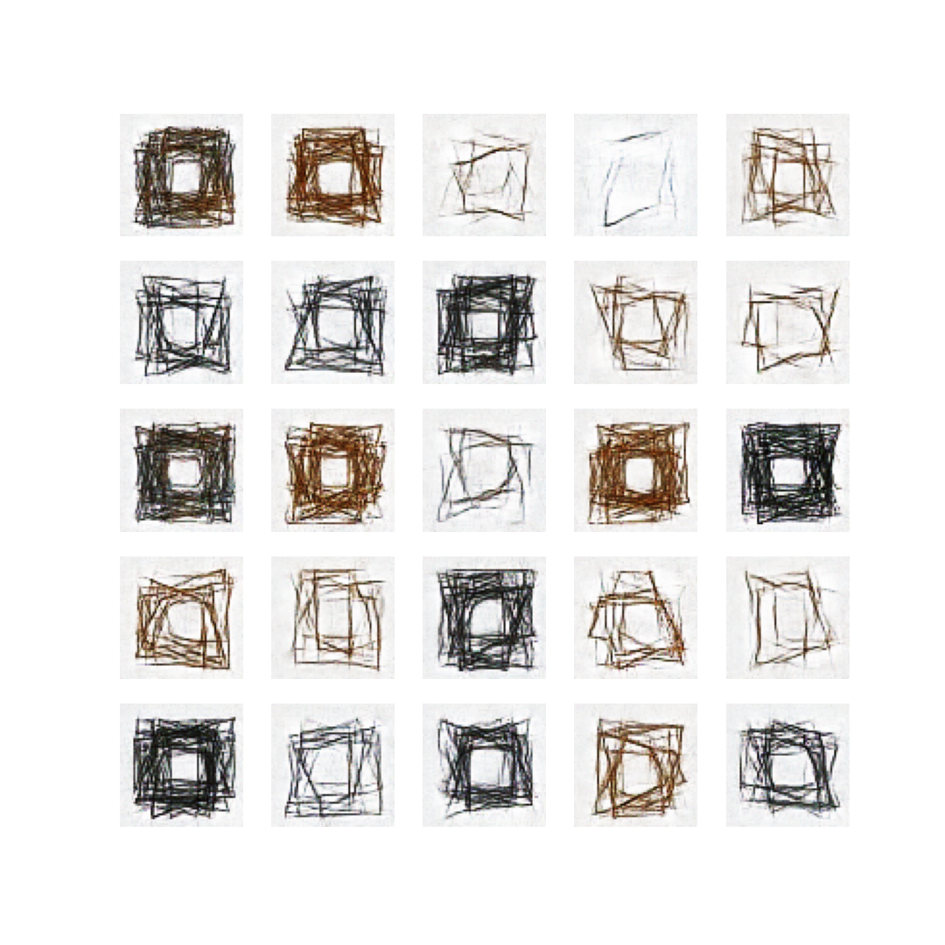
Discovering GANs – Training the GAN
Structure de quadrilatères, Vera Molnar, 1985
Tristan Debeaune & Wendy Gervais

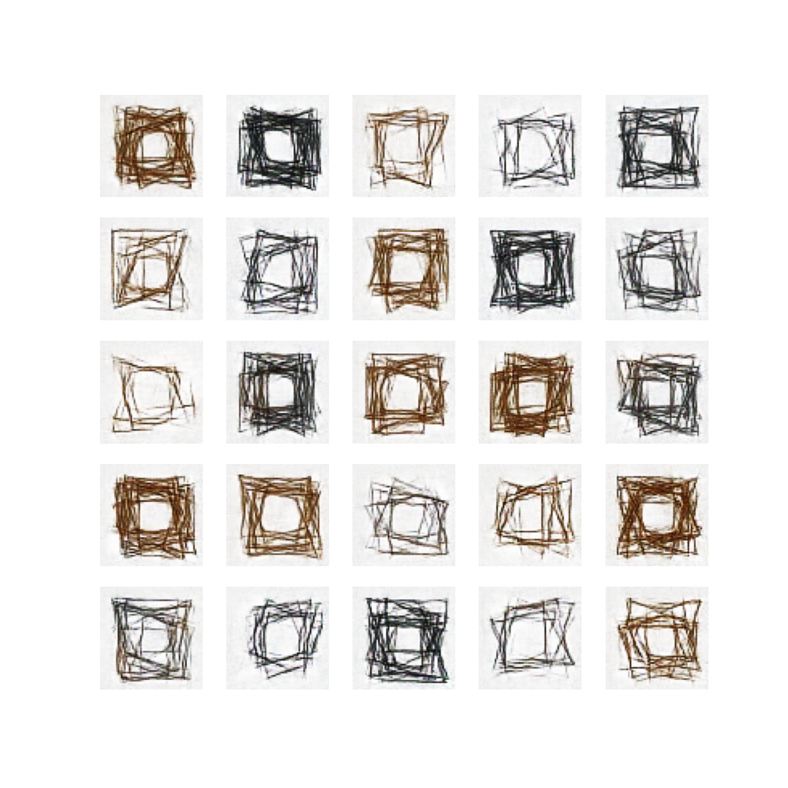
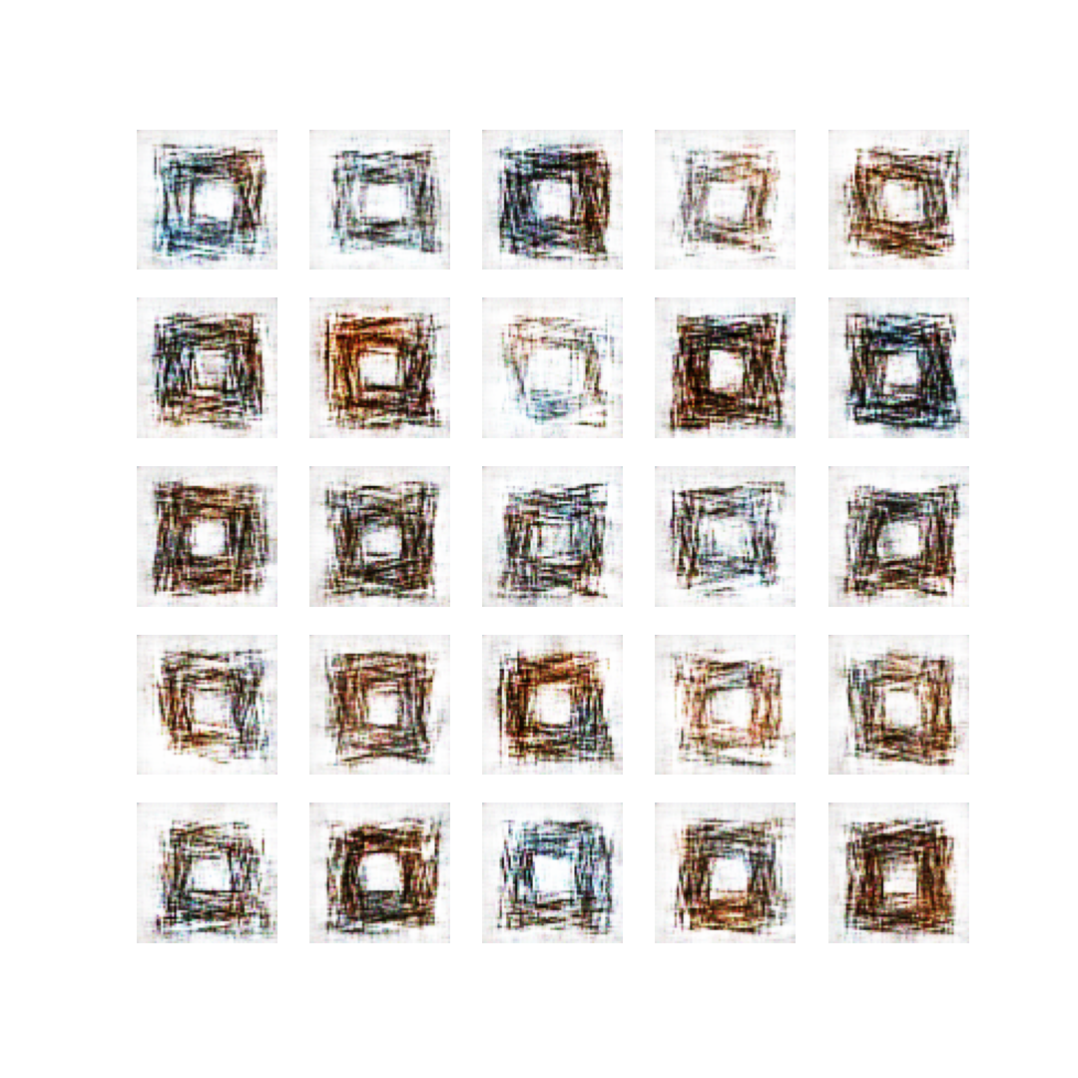

Sample 4200
Sample 6000
Sample 300

We trained the GAN with our 10k dataset. We asked it for around 6000 epochs; from the very beginning we could recognize black and brown quads, after nearly 4000 of them the result was very convincing. It managed to recreate the huge diversity in density, colors and dispositions of angles, eventhough the lines are a bit noisy and blurry, especially when the density of lines is small (e.g sample 6000, line 1, rows 3 and 4), they are shaky and less perceptible as if they were drawn with a pen, which is somehow interesting.
Otherwise the results are, to us, very accurate!

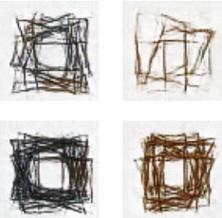
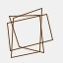
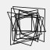



4 from dataset
4 from output (sample 6200)

